**10 QPSK MODULATION AND DEMODULATION**

**10.1 Objective**

To analyze a Carrier Modulation Techniques by Quadrature phase shift keying method.

**10.2 Hardware Required**

QPSK Tranier kit – ADCT-2/ADCT-03 (Kitek Technologies).

Digital Storage Oscilloscope (DSO)

Patch Chords

**10.3 Introduction**

Quadrature PSK (QPSK) is also called 4-PSK. In QPSK, two bits of digital information is sent at a time without the use of another carrier frequency. The amount of radio frequency spectrum required to transmit QPSK reliably is half that required for BPSK signals, which in turn makes room for more users on the channel.

The following figure shows the QPSK waveform.

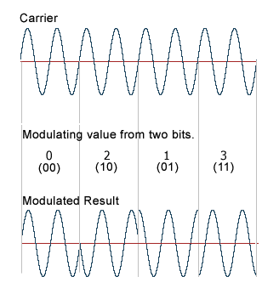

**Figure 10.1 QPSK Waveform**

**Block Diagram**

QPSK modulator and depmodulator is repreented in figure 10.1 and 10.2 repectively

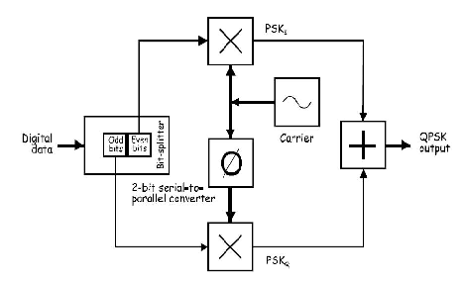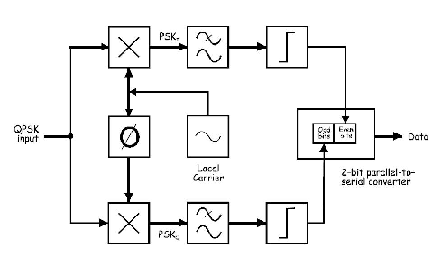

**Figure 10.2 QPSK Modulator Figure 10.3 QPSK Demodulator**

**Generation of QPSK Signal:**

The QPSK Modulator uses a bit-splitter, two multipliers with local oscillator, a 2-bit serial to parallel converter, and a summer circuit. At the input of the modulator, the digital data stream gets splitted into even and odd bits by a bit-splitter. The even bits (i.e., bits 0,2,4 and so on) gets multiplied with a carrier to generate a BPSK signal (called PSKI). At the same time, the data’s odd bits (i.e., bits 1,3,5 and so on) and are multiplied with the 90゜ phase shifted version of same carrier to generate a second BPSK signal (called PSKQ).

The two BPSK signals are then added together for transmission and, as they have the same carrier frequency, they occupy the same portion of the radio frequency spectrum. While this suggests that the two sets of signals would be irretrievably mixed, the required 90゜ of phase separation between the carriers allows the sidebands to be separated by the receiver using phase discrimination.

**Reception of QPSK Signal:**

Figure 10.3, shows the block diagram of the mathematical implementation of QPSK demodulation. The QPSK Demodulator uses two product demodulator circuits with local oscillator, two band pass filters, two integrator circuits, and a 2-bit parallel to serial converter.

The two product detectors simultaneously demodulate the two BPSK signals, which simultaneously recovers the pairs of bits in the original data. The two signals are cleaned-up using a comparator or some other signal conditioners then the bits are put back in order using a 2-bit parallel to serial converter.

**10.4 Prelab Questions**

1. The bandwidth of QPSK signal is ______ the bandwidth of BPSK signal.

(a) Half (b) Twice (c) same as (d) one-fourth

2. The constellation diagram of QPSK has ______ points

(a) one (b) two (c) three (d) four

3. QPSK sends ______ bits of digital information at a time. It is also called ________.

(a) 1, dibit (b) 2, dibit (c) 3, dibit (d) 4, dibit

4. QPSK is also called ____________________________________.

5. Draw the signal space diagram of coherent QPSK system.

**10.5 Procedure**

***Note: Keep the Fault Switch Normal Position as shown*.**

|  |  |  |  |  |
| --- | --- | --- | --- | --- |
|  | **1** | **2** | **3** | **4** |
| **ON** |  |  |  |  |
| **OFF** |  |  |  |  |

1. Connect the AC Supply to the Kit
2. Ensure that all faults are in normal position
3. Make connections and settings as shown in block diagram 10.6
4. Select data pattern of simulated data using switch SW 1
5. Connect DATA to DATA IN of the NRZ-L CODER
6. Connect NRZ-L DATA to DATA IN of the DIBIT CONVERSION
7. Connect SCLOCK TO CLK IN of the DIBIT CONVERSION
8. Connect the dibit data I & Q bit to control input C1 and C2 of CARRIER MODULATOR respectively.

**NOTE: Adjust I & Q bit as shown in Fig. 12 by operating RESET Switch on ADCT-02 before connecting it to C1 & C2.**

1. Connect carrier component generated by carrier generator to input of CARRIER MODULATOR as follows:

**a. SIN 1 to IN 1; b. SIN 2 to IN 2; c. SIN 3 to IN 3; d. SIN 4 to IN 4**

1. Connect QPSK modulated signal obtained at MOD OUT on ADCT-02 to the MOD IN of the QPSK DEMODULATOR on ADCT-03

**NOTE: Adjust Recovered I & Q bit on ADCT -03 as per I & Q bit on ADCT- 02 by pressing the phase sync. Switch provided on ADCT-03**

1. Connect I BIT, QBIT & CLK OUT outputs of QPSK Demodulator to I BIT IN, Q BIT IN & CLK IN posts of Data Decoder respectively**.**
2. Observe various waveforms as mentioned below Fig. 10. 4 and 10.5.

**NOTE: If there is delay in input & recovered Data, then adjust that Delay by pressing the RST Switch on ADCT-03**

1. Observe the following waveforms on oscilloscope and plot it.

**ON KIT ADCT-02**

* 1. Input NRZ-L Data at DATA IN of dibit conversion.
  2. Carrier frequency SIN 1 to SIN 4
  3. Dibit pair generated data I bit & Q bit at DIBIT CONVERSION
  4. QPSK modulated signal at MOD OUT.

**ON KIT ADCT-03**

* 1. Recovered data bits (I & Q bits) at the output of ENVELOP DETECTORS.
  2. Recovered NRZ-L data from I & Q bits at the output of DATA DECODER

**Observation**

|  |  |  |  |  |  |
| --- | --- | --- | --- | --- | --- |
| **QPSK Modulation (ADCT – 02)** | | | **QPSK Demodulation (ADCT – 03)** | | |
| **Output** | **Amplitude** | **Time Period** | **Output** | **Amplitude** | **Time Period** |
| **NRZ-L Data** |  |  | **Clock** |  |  |
| **Carrier Frequency**  SIN 1  SIN 2  SIN 3  SIN 4 |  |  | **Envelop Detector**  DEM I  I bit  DEM Q  Q bit |  |  |
| **DIBIT Conversion**  I Bit  Q Bit |  |  | **Data Out** |  |  |
| **QPSK Modulated Signal** |  |  |  |  |  |

|  |  |  |  |  |
| --- | --- | --- | --- | --- |
| **DIBIT** | **00** | **01** | **10** | **11** |
| **PHASE SHIFT (degrees)** | 180 | 90 | 270 | 0 |

**10.6 Model Graph**

**QPSK Modulation**

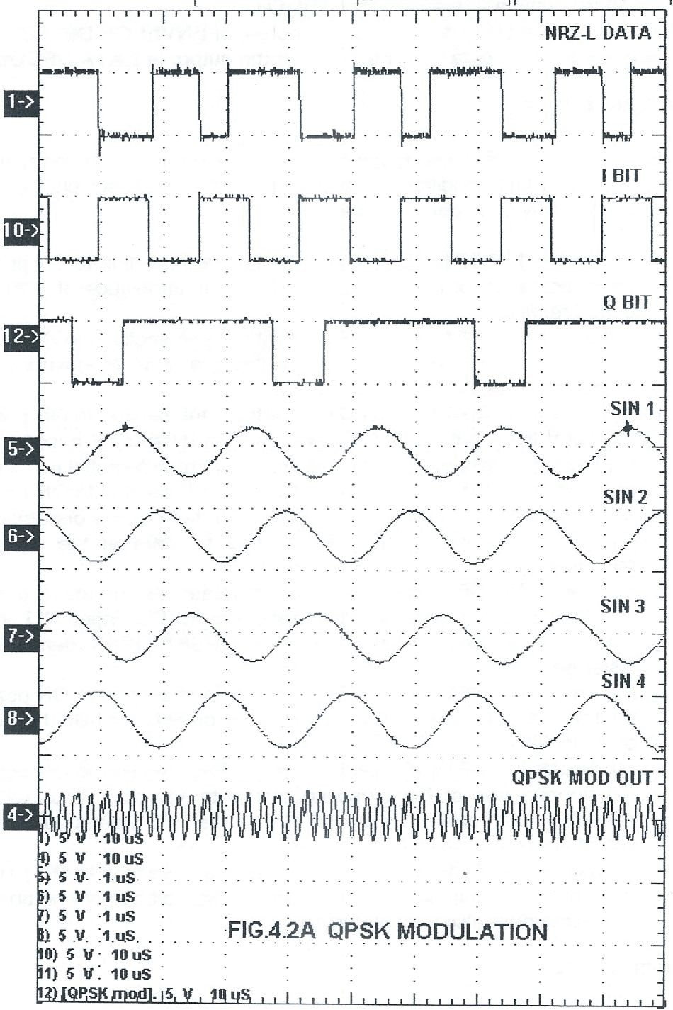

**\* Take Time Period for any one pulse.**

**Figure 8.4 DM Waveforms for AC input signal**

Fig. 10. 4 QPSK Modulation

**QPSK Demodulation**

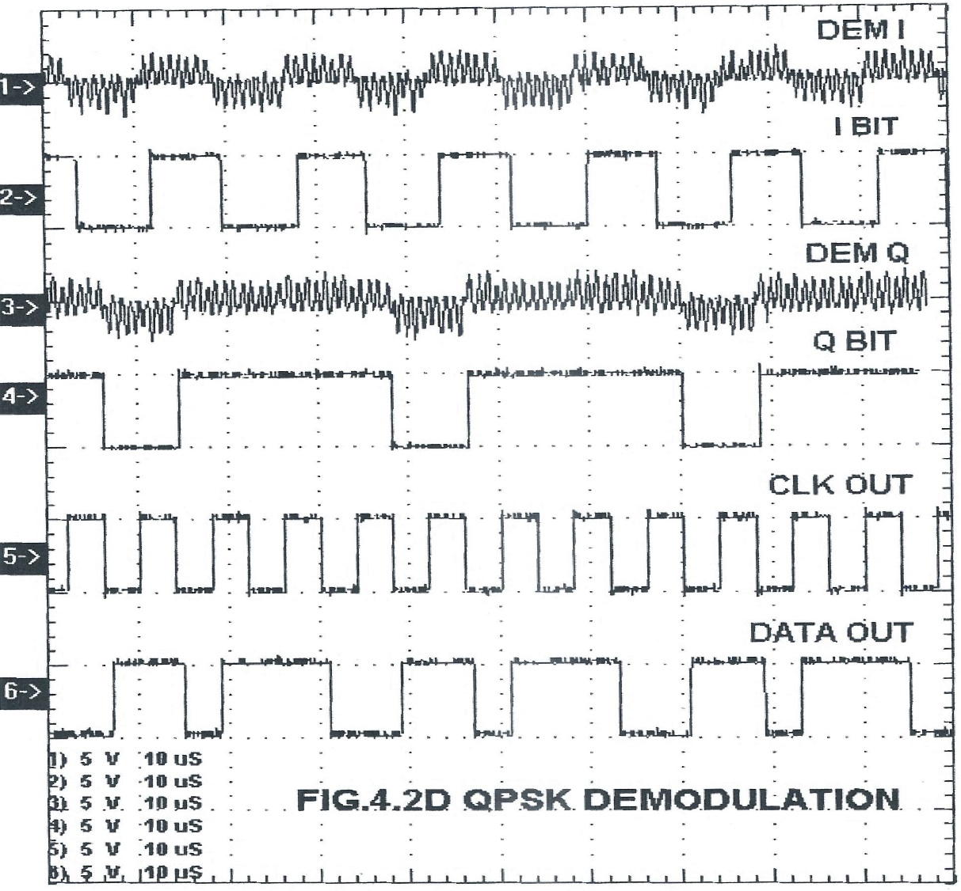

Fig. 10.5 QPSK Demodulation

**10.7 Post-lab Questions:**

1. Define baud rate.
2. What is the symbol rate for QPSK modulation scheme is the information rate is 900 bits/sec and FEC (forward error correction code) is 3/4
3. Compare QPSK and OQPSK.
4. Write the mathematical equation for QPSK signal and plot its constellation diagram.

**10.8 Lab Result**

Thus, the QPSK modulation and demodulation were performed using the trainer kit.

# (

Fig.10.6 QPSK Modulation Demodulation Trainer Kit ADCT – 02 / ADCT - 03